Product Specification Bulletin – Page 1 of 6

PAVE-EL• Paver Pedestal Models: 4X, 5X, 6X, 7X

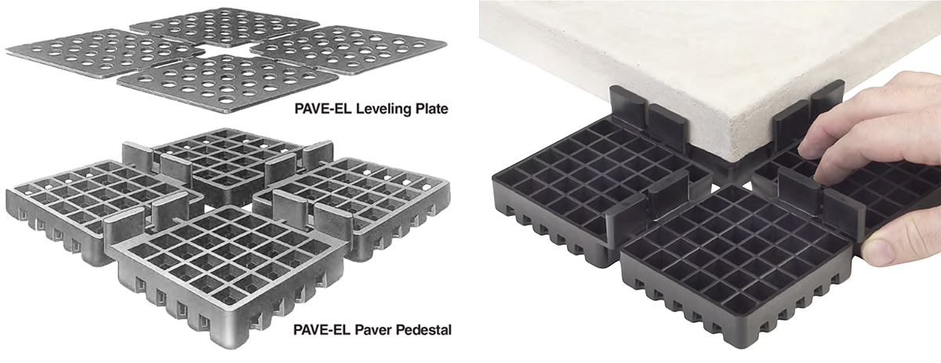

Paver Pedestals for Waterproofed Projects – In Use for over 40 years!

Current Installations include: Smithsonian Institute, NASA Headquarters, FBI Headquarters, University of New Mexico and many more high pedestrian-use rooftops!

- Roof-Decks and Balconies
- Terraces, Podiums, Plazas and Arenas
- Mechanical Walkways
- Swimming Pool Surrounds and Dry Deck Water Fountains

PAVE-EL Paver Stone Pedestal System

The conventional method of setting precast concrete, stone or other type paving slabs into a sand, gravel or mortar bed has had a deleterious effect on many types of promenade and other deck systems.
The entry of surface water into these systems causes pavers to heave due to freeze-thaw cycling, wash-out, break-up, and eventual deterioration of the waterproofing membrane over occupied areas below. The high cost of replacement, leveling and aligning the pavers as well as repairs to the waterproofing, is an ongoing maintenance problem.
The PAVE-EL pedestal system elevates deck surfaces to separate and provide a drainage plane between pavers and the waterproofed supporting structure below. It is designed to meet North American climatic and architectural requirements.

Basic Use: Wherever pavers occur over waterproofed deck areas such as podiums, plazas, arenas, terraces, roof promenades, and swimming pool surrounds. (Note: the PAVE-EL system is not recommended for vehicular traffic applications.)

- Ideal for single-ply membrane applications (see Installation).
- Ideal for protected membrane deck applications.
- Ideal for support pedestals or sleepers used in catwalks, mechanical access walks, balcony deck structures, and roof-mounted piping.

PAVE-EL® is a registered trademark of Envirospec Inc.

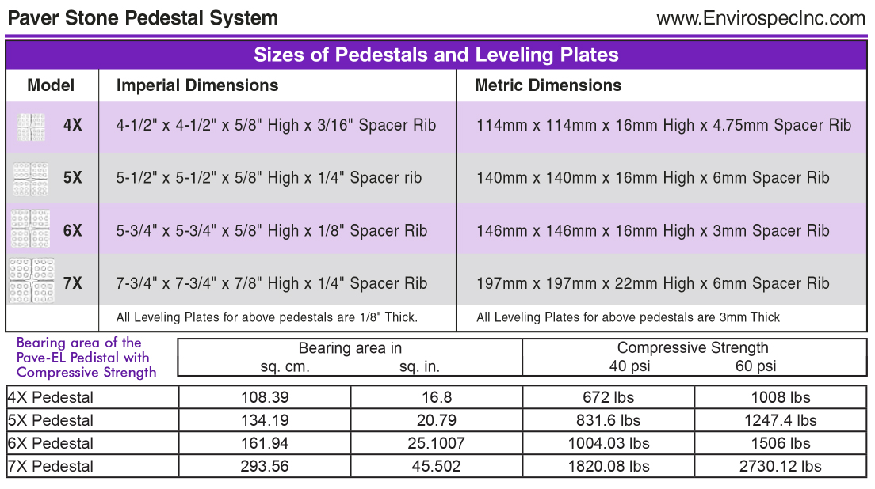
Technical Data

Low Temperature Brittleness (ASTM D746): -94°f (-70°C)
Resistance to Ultra-Violet: UV stabilized – eliminates problems often associated with similar products.
Hardness, Shore D (ASTM D2240): 65
Softening Point (Vicat // ASTM D1525): 264°F (129°C)
Weatherability: Unaffected by freeze-thaw cycling, ozone, humidity, and is not water absorbent.
Sound Transmission Loss: Resilient. high-density polyethylene reduces sound transmission to occupied areas.

Features

Pedestal elevates and levels paver stones, incorporating a unique through-drainage and air-vent design that eliminates water entrapment and freeze-thaw damage at paver slab corners. Elevated position of pavers reduces heat conductance to and subsequent expansion of waterproof membrane. For general shimming, the placing of proprietary PAVE-EL leveling plates over pedestals, as required, will surface align one paver with the next and compensate for minor deck and paver discrepancies. Leveling plates may similarly be separated into halves and quarters for individual paver stone adjustment. Horizontal leveling of critical surfaces, if required, may be achieved by multiple stacking of pedestals and leveling plates.

Architectural/Engineering Specifications

NOTE Applicable to Models 4X, 5X, 6X and 7X: Unit to be a grid-like structure constructed of high-density polyethylene (In black) with integral spacer ribs located on the upper surface to ensure even joint spacing. Pedestals may be separated into halves or quarters to accommodate perimeter-edge and corner support. Leveling plates only 1/8" (3mm) thickness. Installed in accordance with manufacturer's written Instructions to areas shown on the drawings.

Model 4X Paver Stone Pedestal: Unit paver support pedestals to be PAVE-EL Model 4X as manufactured by Envirospec Inc. to suit a paver stone measuring ___ in/mm long x ___ in/mm wide and ___ in/mm thick.

Unit size to be 4-1/2" x 4-1/2" x 5/8" high x 3/16" spacer rib (114mm x 114mm x 16mm x 4.75mm spacer rib).

Model 5X. Paver Stone Pedestal: Unit paver support pedestals to be PAVE-EL Model 5X as manufactured by Envirospec Inc. to suit a paver stone measuring ___ in/mm long x ___ in/mm wide and ___ in/mm thick.

Unit size to be 5-1/2" x 5-1/2" x 5/8" high x 1/4" spacer rib. (140mm x 140mm x 16mm high x 6mm spacer rib.)

Model 6X Paver Stone Pedestal Unit paver support pedestals to be PAVE-EL Model 6X as manufactured by Envirospec Inc. to suit a paver stone measuring ___ in/mm long x ___ in/mm wide and ___ in/mm thick.

Unit size to be 5-3/4" x 5-3/4" x 5/8" high x 1/8" spacer rib. (146mm x 146mm x 16mm high x 3mm spacer rib.)

Model 7X Paver Stone Pedestal Unit paver support pedestals to be PAVE-EL Model 7X as manufactured by Envirospec Inc. to suit a paver stone measuring ___ in/mm long x ___ in/mm wide and ___ in/mm thick.

Unit size to be 7-3/4" x 7-3/4" x 7/8" high x 1/4" spacer rib. (197mm x 197mm x 22mm high x 6mm spacer rib.)

(scroll down to continue)…
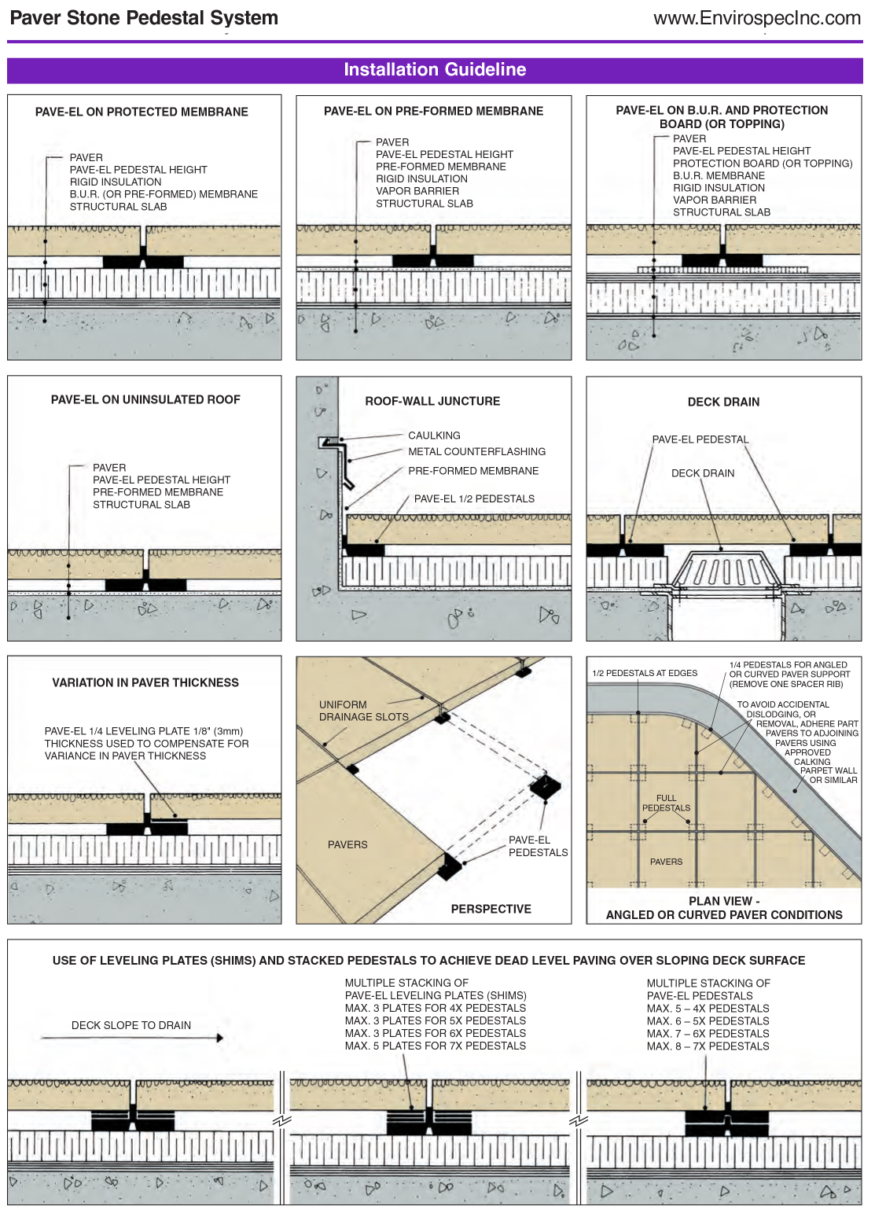
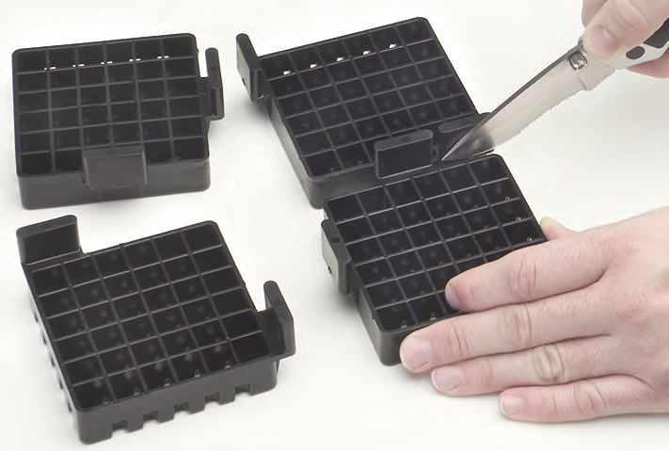
PAVE-EL pedestals and leveling plates (shims) are easily divided into halves and quarters by cutting units at polyethylene bridge points.

Installation: Bituminous waterproofing membranes are subject to softening at high ambient temperatures. It is recommended that protection board or topping be used under the PAVE-EL pedestal to decrease point load pressure on the membrane.
- Protected roof membrane insulation manufacturers recommend the PAVE-EL system. Consult with single-ply membrane manufacturer, insulation manufacturer and Envirospec Inc. if uncertain about compatibility between membrane and pedestal. The PAVE-EL system is recognized and accepted for use by single-ply membrane manufacturers.
- On deck perimeter and around protrusions where it is not practical to cut pavers to fit (i.e. canted roof-wall junctures), coarse gravel with binder (if desired) may be used in voids.
- PAVE-EL system was designed specifically for use with square or rectangular pavers. Consult with Envirospec Inc. for use with other shapes. (Note: The PAVE-EL system is not recommended for vehicular traffic applications.)

Pedestal Requirements: Use basically the same number of pedestals as pavers on square or rectangular decks. Columns and other protrusions, where pavers are cut and fit, will increase number of pedestals required.

Leveling Plate Requirements: For general shimming adjustments, approximately 10 leveling plates per 100 pedestals are required. Irregular deck surfaces or pavers of varying thickness will increase number required.

Horizontal Leveling: On deck areas where a dead level paver surface is desired, full shimming with leveling plates and multiple stacking of pedestals is utilized. A greater number of plates and pedestals are required to accomplish this condition and should be estimated for accordingly.

Methods: No special tools or skill required for installation.

- Following predetermined layout, locate first row of paver stones at an exterior edge of deck, using 1/2 pedestals at edges and 1/4 pedestals at corners and at partial angled paver locations.
- Place pedestals with projecting ribs facing upwards to ensure uniform paver stone joint spacing. Place pavers tight to spacer ribs to ensure even spacing.
- Place paver stones by lowering horizontally rather than nosing into position to eliminate possible indentation of insulation on protected membrane roofing system. Align and shim as required as work progresses.
- Run subsequent rows of pavers parallel to first row.
- Where multiple stacking of pedestals is employed, locate leveling plates on top of upper pedestal, never in-between or below pedestals.
- On deck perimeter and around protrusions where it is not practical to cut pavers to fit (i.e. canted roof-wall junctures), fill voids with coarse gravel [and binder].

Availability: Distributed throughout the United States, Canada and worldwide.
Cost: Current price list and estimating data available upon request.

Warranty: All PAVE-EL pedestals carry a 20-year warranty against faulty materials. No other implied or expressed guarantee is made by the manufacturer.

Maintenance: The PAVE-EL system is self-cleaning. Pedestals may be re-used if removed for any reason.
For access to substrate areas, pavers simply lift out of position. Easy to replace damaged pavers as well.

Technical Services: Envirospec Inc. provides a consultation service from preliminary design through to product application. Do not hesitate to contact our office regarding any questions or for specific detailing.

CONTACT:

Phone: 905-271-3441

info@envirospecinc.com

www.envirospecinc.com

Head office: 21 Mellowood Drive, Toronto, Ontario, Canada M2L 2E4

Warehouse locations: Western New York, Colorado, Vancouver, B.C. and Toronto, ON, Canada.

